**MECH 447 Project 4**

Detonations

Louis Bourque – 260714602

Dec 20th, 2020

**Introduction**

For this project, we intend to analyze the detonation and deflagration cases of a stoichiometric carbon monoxide/oxygen system. This system thus has the initial conditions of 1 atm, 298 K, and a ratio of 2:1 between CO and O2. To analyze the detonation, two methods will be used to graph the cases, a perfect gas solution, and an equilibrium solution. For these, we will be heavily using the NASA CEA program to analyze the system through various points of the shock.

Throughout all of this however, it is important that the detonations are assumed to be properly described by the ZND model. This model imposes that a detonation is split between the shock wave and the reaction, with the non-reacting shock wave first passing through the mixture, and then the reaction following behind it. Of this model, several points are important to note. The first is the von Neuman point, where the inert shock begins, meaning that the system acts much like a fluids problem with no change in chemical composition. As the shock travels, it approaches the Chapman-Jouguet Point, where the flow velocity in the reference frame becomes sonic. Following this, the weak detonation curve follows the isentropic line to the constant volume solution, where any point beyond in the detonation is considered not physical.

Following the non-physical region, the deflagration zone can be observed with another Chapman-Jouguet Point that shows the point of fastest possible deflagration with a sonic outflow. Overall, the line that follows form the von Neuman, through the strong and weak detonation, and finally through the deflagration zone is called the Hugoniot curves on a (*p,v*) diagram.

Thus, for both the perfect gas and equilibrium approach, we will plot the Hugoniot curves to study the differences in assumptions and approaches.

**Part 1: Perfect Gas Assumption – Constant γ**

To begin, the assumption that a gas is perfect requires us to determine a proper value for γ, or the specific heat ratio:

$$γ=\frac{c_{p}}{c_{v}}$$

Along with this, we must solve for the heat release of the reaction *q* by solving for the difference in enthalpy of formation of reactants and products:

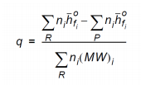

Using NASA’s CEA program to solve for the Chapman Jouguet Point, we can easily solve for the heat release by using output of mole fractions and known enthalpy of formations for the species. As for the specific heat ratio, the reaction and change of gas composition affects the ratio and thus is realistically not constant. To make the perfect gas assumption, the initial γ and final γ were simply averaged to a value of 1.2615. Though a more thorough method could be used, the range of γ is so small that the variations themselves would not meaningfully affect the final product.

Following this, the heat of reaction was non-dimensionalized by the heat capacity and temperature of the initial composition as such:

$$Q=\frac{Δq}{c_{p}T_{1}} = 13.1785$$

Knowing γ and Q, we can thus plot the Hugoniot curves for both the reacting shock and the non-reacting shock through the following equation:

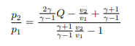

From this, the pressure ratio (P2/P1) is the independent variable, while we vary the volume ratio (v2/v1) throughout the curve.

Along with the curves, the Rayleigh lines are also included for the appropriate detonation and deflagration solutions according to the following equation:

$$\frac{p_{2}}{p_{1}}=γ{M_{CJ}}^{2}\left(1-\frac{v_{2}}{v_{1}}\right)+1$$

Along with this, the Rayleigh line for the overdriven detonation propagating at 3500 m/s is plotted with its Mach number of 10.2041 being found by dividing the propagation speed by the speed of sound in the original chemical composition of 343 m/s.

Finally, the von Neuman Point is found by finding the intersection of the Rayleigh line with the non-reaction Hugoniot curve, and further checked through the following equations:

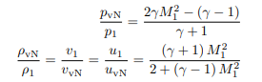

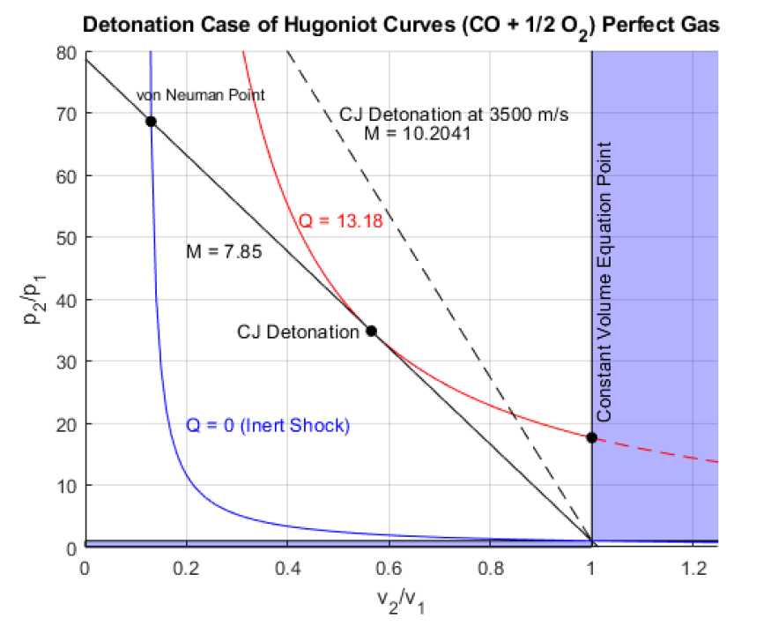

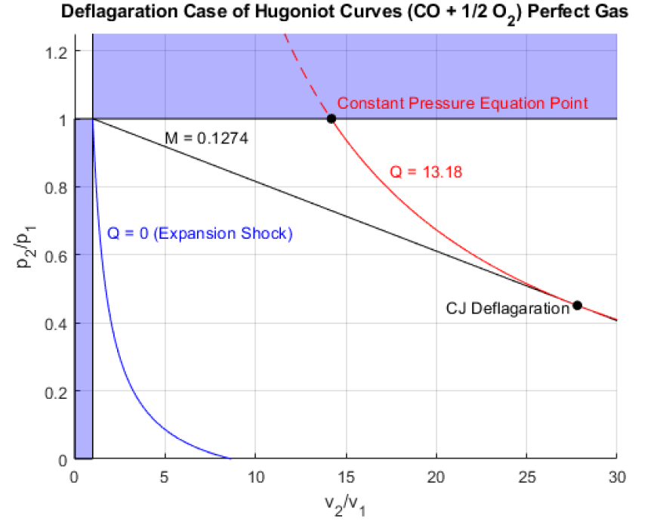

**Part 2: Equilibrium Solution**

As opposed to the previous part where the Hugoniot curves were solved through equations relating to γ and Q, we will now plot the curves through a full chemical equilibrium approach.

Once again, we can use CEA to plot both the non-reacting curves and the reacting curves, along with Rayleigh lines and Chapman-Jouguet solution points. As CEA already gives the pressure ratio, it is simply a matter of determining the volume ratio in order to plot the curves. This is done by using the fact that mass is conserved, meaning that the density ratio is simply reduced to the inverse of the volume ratio.

With this in mind, we can now plot the strong detonation and inert shock. Due to limitations in the CEA program, only the strong detonation branch is output, meaning that a separate method is required to plot the weak detonation branch.

This was done through the use of the CEA’s assigned enthalpy and pressure solution (h,p) and keeping the solution in a frozen state. Knowing that the start of the weak detonation branch was at the CJ solution, and that the end was at the constant volume point, we can ensure that the CEA output is correct.

Furthermore, the isentropic curve can be plotted through the use of the (s,p) or (s,v) CEA problems. By solving for the entropy from the specific entropy at the CJ point like so:

$$s=\frac{S}{ρ}\frac{1}{\frac{v_{2}}{v_{1}}} = 1.001809 g-mol/g$$

The isentropic line is plotted through the (*p,v*) diagrams. This is important as we know that the weak detonation branch follows the isentropic curve, and thus we expect the solved weak detonation and the plotted isentropic curve to be one and the same.

From the graphs, we can clearly see that the weak detonation and isentropic line do indeed match and converge on the Constant Volume point. Furthermore, the strong detonation curve seems to move away from the isentropic curve and toward the inert shock the farther away from the CJ solution and closer to the von Neuman point it gets.

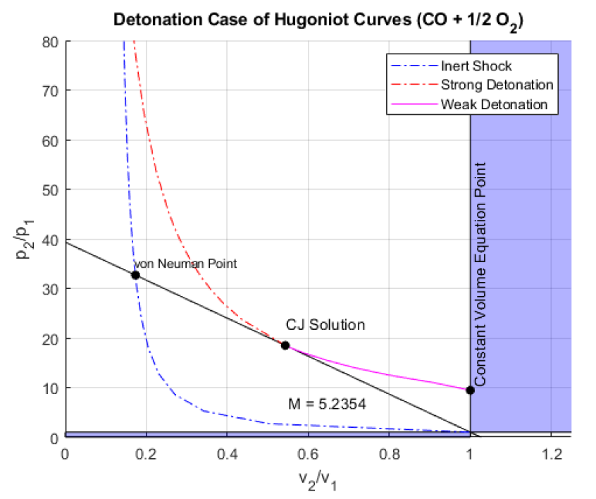

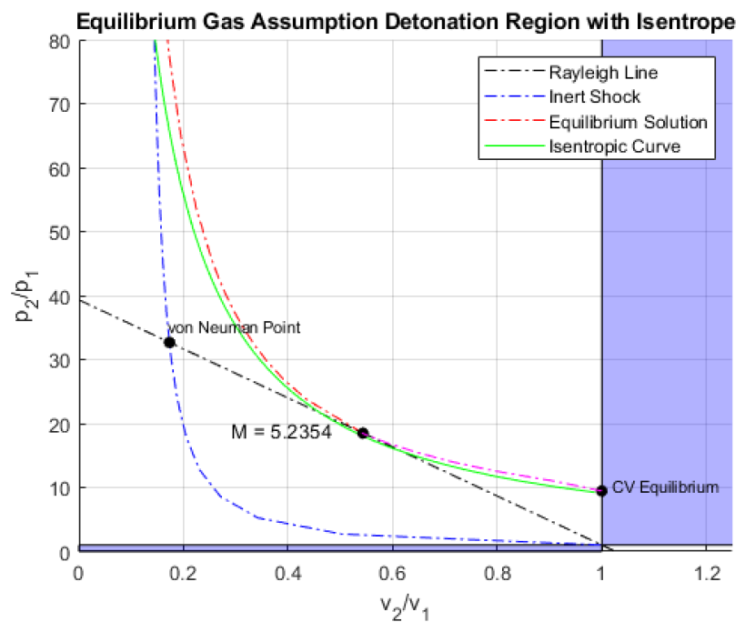

With both the perfect gas and equilibrium solutions plotted, we can thus overlay and compare the two:

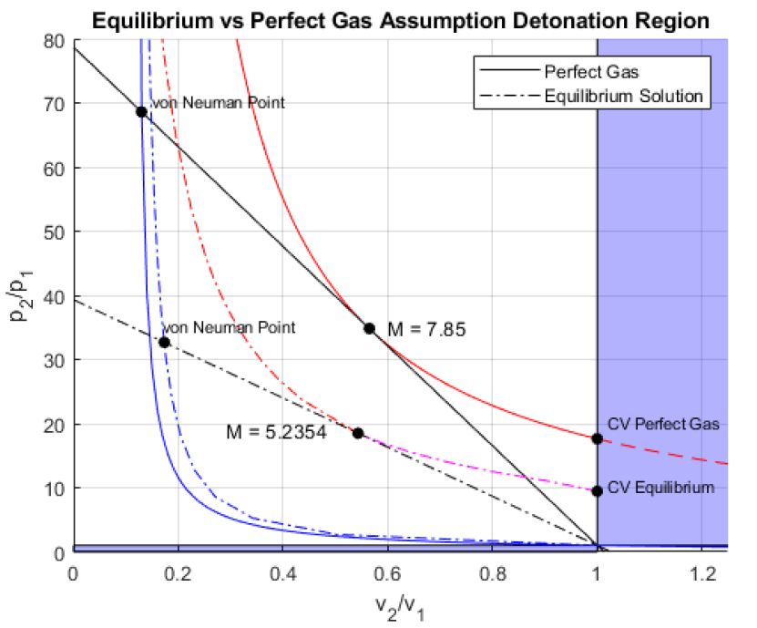

From this, we can clearly see that the perfect gas assumption has a much higher shock speed at the Chapman-Jouguet Solution point. Following this, this means that the Perfect Gas curve has a much higher pressure ratio at the von Neuman point and constant Volume solution point than the equilibrium solution. Interestingly however, the Equilibrium Solution’s inert shock curve is at a higher volume ratio along with its von Neuman Point. This might be due to the assumption that a perfect gas has no intermolecular forces, which would affect the mixture much more in small volumes. This would explain why the error between the two assumptions is much larger at smaller volume ratios. This can be seen also at the constant pressure point in the deflagration region where a bigger volume is needed for the perfect gas to reach the constant pressure point than the equilibrium gas.

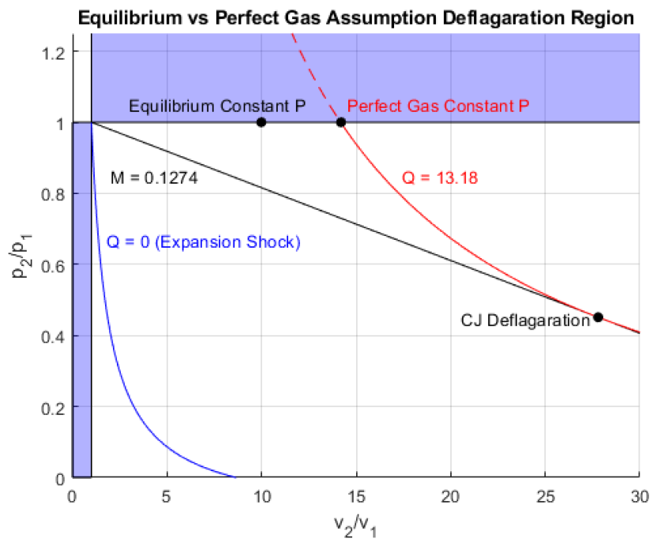

Table 1: Comparison of CJ Solution Points

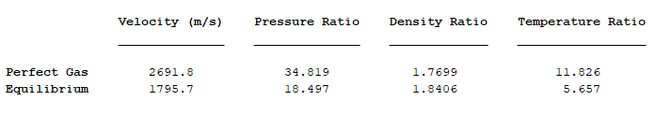

If we wanted to improve the perfect gas Hugoniot curve, the first step would be to properly determine the specific heat ratio of the reaction. As the relationship between the von Neuman point and CJ point is non-linear, the initial assumption that γ is simply the average of the pre-reaction and post-reaction values is faulty to begin with. Since the reaction has most of its heat and combustion near the CJ point at the point of highest heat, then γ should be closer to the initial value of the mixture. This lower value would result in lower pressures and a closer fit to the equilibrium function as it is directly related to the pressure ratio as seen in the equations for Part 1.

**Part 3: Structure of CO/O2 Detonations**

Finally, the final part of the project is to evaluate the full ZND structure of the CO/O2 Detonation using the SDT toolbox in Cantera. As seen in Project 2, multiple mechanisms can be used to setup the gas structure in Cantera and we had gone through multiple such as the gri30, Galway, and San Diego mechanisms. For this detonation however, we begin with the Davis2005 mechanism that involves a multi-step mechanism to solve the mechanisms of the detonation. However, this mechanism proved to be too complicated for any immediate use and thus required optimization for our specific case. First, all reactions other than the three detailed in Project 2 were removed, leaving the mechanism to only evaluate:

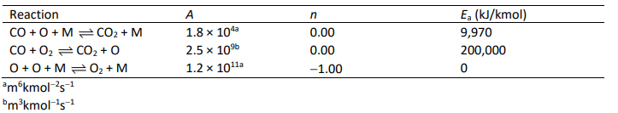

In this case, the M term represents any possible species present in the reactions. As Davis2005 uses an ideal air comprised of numerous trace elements for the three-body reactions involving M, the idea air also had to be modified to only include C, CO, O, and O2.

Thus, using the initial temperature and pressure, along with this newly modified 3 step mechanism derived from Davis2005, the CJ solution and ZND structure can be solved and plotted.

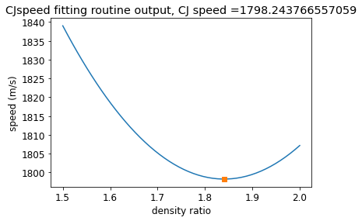

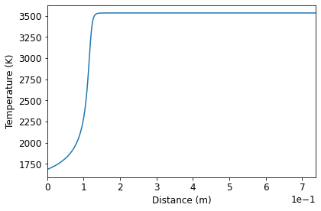

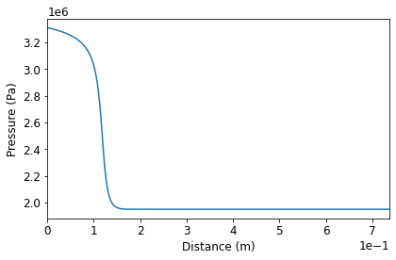

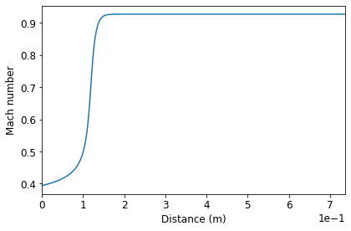

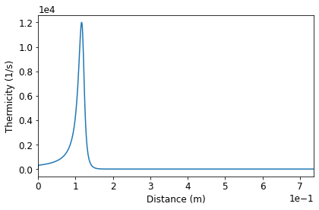

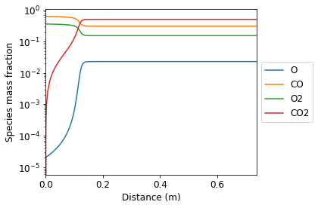

Most important of these graphs is the thermicity spike at about 0.1 m. Thermicity represents the influence of the chemical reaction on the flow velocity. This spike shows when the system experiences the most change along with when thermicity drops to zero. When at zero, thermicity represents when the system’s flow velocity is equal to the frozen sound speed found at the von Neuman point, thus meeting the sonic condition. Knowing from the ZND structure, the maximum change in the chemical reaction is right before sonic conditions are met as energy flows into the mixture during a subsonic Rayleigh flow. This is clearly shown in all other plots, most notably the Mach number and the species mass fractions. For the flow velocity, the subsonic flow accelerates towards sonic as heat is input, with sonic being reached at the saddle point of thermicity at around .15 m. For species mass fraction, the initial conditions are mostly maintained with the largest change in mass fractions coming at the saddle point where the system fully reacts in all its sub-mechanisms and reaches equilibrium at around 0.15 m.

These relationships can also be shown for temperature and pressure where the subsonic Rayleigh flow resulting from the original inert shock at the von Neuman point proceeds to have heat input and reacts to reach the sonic Chapman-Jouguet Point.

**Conclusion**

Overall, this project has shown the difference in Hugoniot curves for a perfect gas solution compared to a chemical equilibrium solution. It is clearly shown that a perfect gas results in a much faster flow resulting in higher pressures at the CJ and von Neuman points, while also having smaller volume ratios for its inert shock response. To properly correct this, it is recommended to properly evaluate a better specific heat ratio value for the perfect gas solution. This is due to the reaction not happening evenly throughout the strong detonation branch, meaning that the specific heat ratio only truly changes near the end. This leads to the true average guess to be lower. This would result in a more realistic solution with pressure ratios much closer to the ones seen in the chemical equilibrium curves.

Furthermore, the weak detonation curves were able to be plotted through the use of frozen compositions past the Chapman-Jouguet point. This supports the idea of the ZND structure where the reaction follows the inert shock wave and adds heat until sonic conditions are met. After these sonic conditions, the weak detonation wave is shown to follow the isentropic curve until the constant volume point where the wave no longer becomes feasible. For further studies, it would be interesting to do similar plots but for the deflagration regions with an isentropic curve to see if the weak deflagration curve follows it. This would mean that the reaction would either resume or change equilibrium at the weak Chapman-Jouguet point as it once again no longer meets sonic conditions and adjusts.

Finally, the final part of the project solved for the ZND structure and clearly shows numerically what the ZND theory is. The ZND structure is comprised of a planar inert shock that changes a supersonic flow to subsonic, quickly being followed by a reaction which adds heat to the flow. Following the idea of Rayleigh flow, this heat decreases pressure, increases temperature, and increases flow speed in the direction making the flow sonic. At that point, the CJ solution, the reaction fully completes, and the products can be seen to have reached equilibrium.

**Python Script**

# -*- coding: utf-8 -*-

"""

Created on Fri Dec 18 22:00:59 2020

@author: Louis Bourque

Adapted from SDT toolbox demo ZNDshk

"""

from sdtoolbox.postshock import CJspeed, PostShock_fr

from sdtoolbox.znd import zndsolve

from sdtoolbox.utilities import CJspeed_plot, znd_plot

import cantera as ct

P1 = 101325

T1 = 298

U1 = 1798.244 #From CEA and SDT toolbox

q = 'CO:2 O2:1'

mech = 'My3step.cti'

# Set up gas object

gas1 = ct.Solution(mech)

gas1.TPX = T1,P1,q

# Find CJ speed and related data, make CJ diagnostic plots

cj_speed,R2,plot_data = CJspeed(P1,T1,q,mech,fullOutput=True)

CJspeed_plot(plot_data,cj_speed)

# Find post shock state for given speed

gas = PostShock_fr(cj_speed, P1, T1, q, mech)

# Solve ZND ODEs, make ZND plots

znd_out = zndsolve(gas,gas1,U1,t_end=1e-3,advanced_output=True)

znd_plot(znd_out,major_species = 'All')

print('Reaction zone pulse width (exothermic length) = %.4g m' % znd_out['exo_len_ZND'])

print('Reaction zone induction length = %.4g m' % znd_out['ind_len_ZND'])

print('Reaction zone pulse time (exothermic time) = %.4g s' % znd_out['exo_time_ZND'])

print('Reaction zone induction time = %.4g s' % znd_out['ind_time_ZND'])